When new job/or project is created in Jenkins and also configured with GIT then workspace is created Jenkins folder as exemplified below:

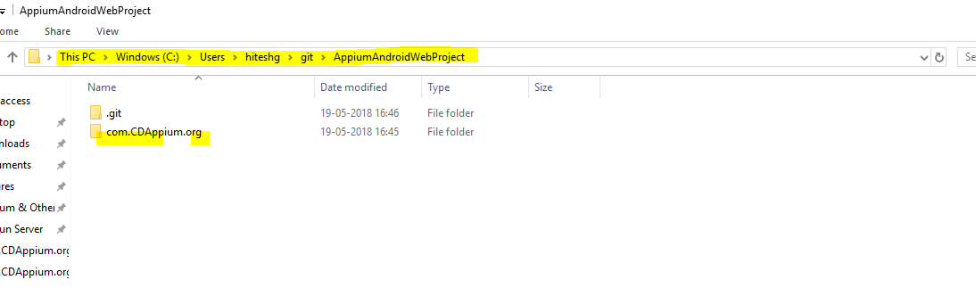

Exception: Sometimes, the following exception may occur while running it from Jenkins.

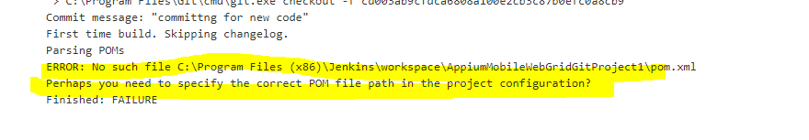

Resolution: This exception can be removed by placing the POM.xml file in the above location. We may have to navigate inside one more folder to place that pom.xml at the project root location. Refer following example:

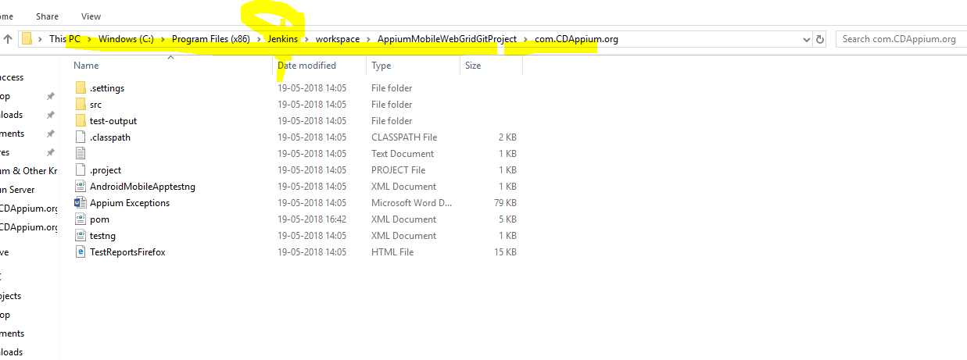

After placing the pom.xml , the exception got removed and project built and ran successfully.